GOVERNMENT OF INDIA
MINISTRY OF WATER RESOURCES
RIVER DEVELOPMENT & GANGA REJUVENATION
GANGA FLOOD CONTROL COMMISSION

Monitoring Report of scheme titled "Khagaria Town protection scheme Part-II (BR-19)" under Flood Management Programme

Est. Cost : Rs. 13.3918 crore

Patna
JUNE, 2018

Monitoring Report of scheme titled "Khagaria Town protection scheme Part-II (BR-19)" under Flood Management Programme

1. Introduction

Khagaria district of Bihar is situated in the left bank of river Burhi Gandak near to its outfall in river Ganga. Khagaria city is also surrounded by number of small rivers. Hence the city is always affected by flood. Right bank of river Bagmati also affects the city during flood. The scheme “Khagaria Town protection scheme Part-II (BR-19) “ for an estimated cost of Rs. 1339.18 lakh was formulated for providing protection from flood to Khagaria Town and the area in the vicinity.

2. Details of Appraisal

The scheme “Khagaria Town protection scheme Part-II (BR-19) “ for an estimated cost of Rs. 1339.18 lakh was formulated for providing protection from flood due to Khagaria Town and the area in the vicinity. The scheme was techno-economically appraised and found in order by GFCC vide its letter No. GFCC/P/341/2007/2620-21 dated 11.04.2008. The investment clearance of the scheme was given by Planning Commission vide its letter No. 12(1)4/2008-WR dated 26.06.2008. The scheme was taken up for implementation under State Sector Flood Management Programme (FMP) with 75% of the cost to be provided by Government of India as central assistance. The scheme was accepted by Inter Ministerial Committee in its 2nd meeting held during August, 2008 for estimated cost of Rs. 1339.18 lakhs out of which the central assistance would be Rs. 1004.39 lakh and the remaining expenditure was to be borne by State Government. Govt. of India released an amount of Rs. 821.77 lakh as 1st installment of central assistance as Rs. 251.00 lakh vide MoF letter no. 41(2)/PF-1/2008- 454 dated 27.01.2009, 2nd installment as Rs. 376.69 lakh vide MoF letter no. 41(4)/PF-1/2009-835 dated 31.03.2010 and the 3rd installment as Rs. 194.08 lakh vide MoF letter no. 41(4)/PF-1/2011- 1273 dated 12.01.2012.

3. Project proposal

The scheme consists of following components.

Restoration to the design sections of right Zamindari embankment along Chanha Nala from 10.40 to 38.20 km.

4. Site Inspection

The site was inspected by officers of GFCC, Patna on 10.06.2018 along with State Government Engineers and the balance works were critically reviewed. The following engineers from GFCC, Patna and WRD, Govt. of Bihar were present during the inspection.
Officers from GFCC and CWC Patna

- Shri Ajay Kumar, Director, GFCC
- Shri Sanjeev Kumar, Dy. Director, GFCC
- Shri O P Singh, Asstt. Director, GFCC

Officers from WRD, Government of Bihar

- Shri Sanjay Raman, SE, Flood Control Circle, Khagaria
- Shri Sunil Kumar Vaishya, E.E., Flood Control Division-II, Khagaria.
- Shri Sanjay Kumar, A.E., Flood Control Division-II, Khagaria.

The site inspected are described below:

- Embankment from RD 25 to 30 km including gaps
- AFS at RD 26.42 km
- AFS at RD 29.20 km

As reported by the WRD, Bihar officials, the project is to be completed by March 2020. Phasing of expenditure as submitted by the State Govt is enclosed as Annex-I.

5. Quality Control Measures

The officers of WRD, Govt. of Bihar have taken Quality Control Measures during the construction of embankment. The sample of cube were taken and tested in Irrigation and Research Institute, Khagaul, Patna. The sample test report made available by WRD, Govt. of Bihar is enclosed at Annex-II.

6. Photographs

The photographs of the sites were taken during inspection and some photographs were collected from the officers of State Govt. which were taken during execution of works. These photographs are enclosed as Annex-III.

7. Present Status and Bottlenecks
The actual construction of scheme was started in the year 2008. The progress of the work is slow and needs to be expedited. As per the information provided by WRD, Govt. of Bihar, the scheme was approximately 78 % completed in the year 2012 and since then the balance work related to 3.85 km of embankment (Bhabhangama mauza) is held up due to land acquisition issues. It was informed that the process of land acquisition is now in advanced stage. It was also intimated that Rs. 10 cr. has already been deposited with Special Land Acquisition Officer, Bhagalpur for the land acquisition purpose.
During the visit, it was observed that there is lot of encroachment on the constructed portion of the embankment, some patches of embankment are badly damaged / under- sized due to encroachment, wear and tear, misuse of embankment for other purposes etc. At one particular location (at around 25.4 km) it was observed that the slope of the embankment was completely cut by the unauthorised occupants for personal use, thereby making the embankment unsafe. Urgent action is required to be taken up by WRD, Govt. of Bihar in consultation with district administration for removal of encroachment as well as restoration of the embankment. WRD, Govt. of Bihar official should keep constant vigil of already constructed embankment to avoid such damages in future and maintain them properly throughout the length.

8. Status of Release of Central Assistance
Amount in Rs. Crore
I | Estimated Cost |  | 13.3918
II | Central Share |  | 10.0439
III | Eligible Central Share |  | 10.0439
IV | Central Share Released | Year | Amount
 | 1st Installment | 2008-2009 | 2.5100
 | 2nd Installment | 2009-2010 | 3.7669
 | 3rd Installment | 2011-2012 | 1.9408
 | Total release |  | 8.2177
V | Balance Central Share to be released |  | 1.8262

9. Recommendation/Conclusion

Based on the field visit, discussions with concerned officials of WRD, Govt. of Bihar and information furnished by them, as the scheme is already 78% complete, the aforesaid scheme may be continued under FMP as per existing FMP guidelines with a advisory to WRD, Govt. of Bihar to make special and dedicated efforts to complete land acquisition process at the earliest in consultation with district administration so as to complete the work as per revised target date proposed by WRD, Govt. of Bihar i.e. March 2020.
The works are being carried out satisfactorily and the next installment of Central share may be released.

(Ajay Kumar)
Director(P&C)
GFCC, Patna

ANNEX-III
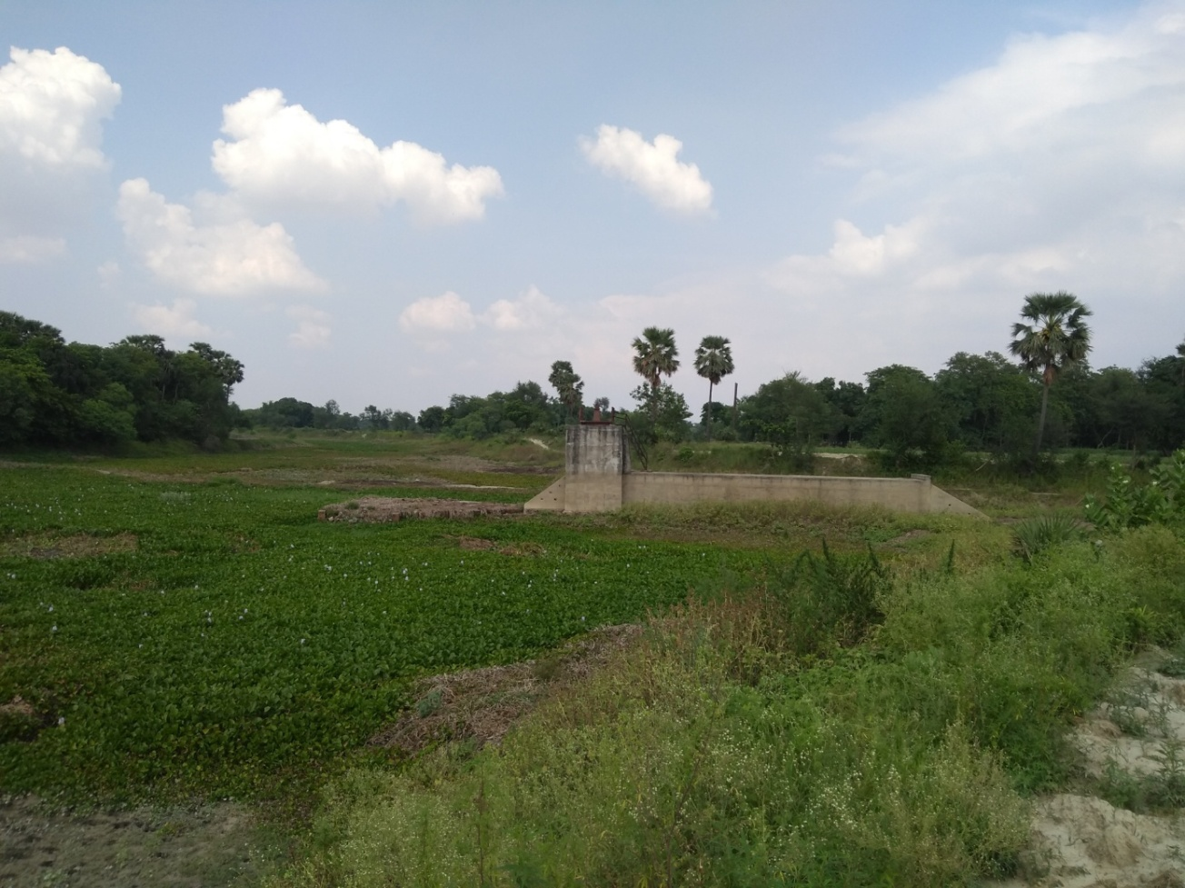
AFS at RD 26.42 km of BR-19: Khagaria Town protection scheme Part-II

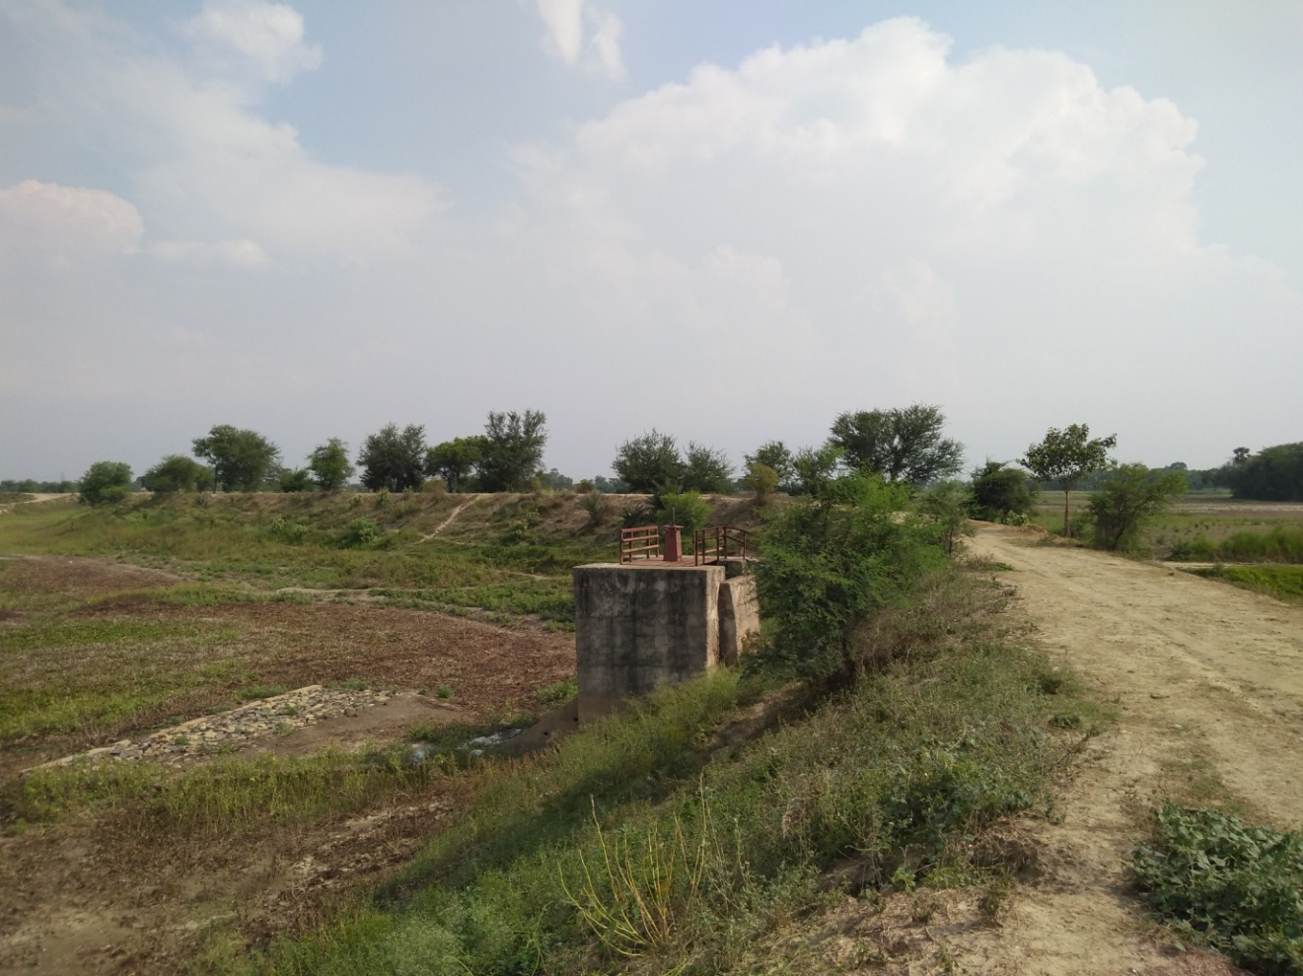
AFS at RD 29.20 km of BR-19: Khagaria Town protection scheme Part-II

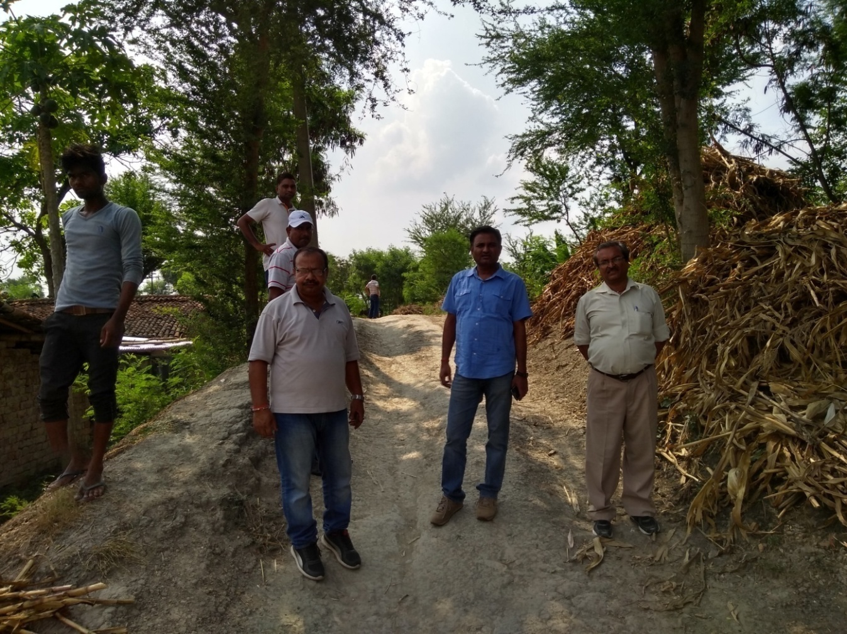
Visit to BR-19: Khagaria Town protection scheme Part-II

