GOVERNMENT OF INDIA
MINISTRY OF WATER RESOURCES
RIVER DEVELOPMENT & GANGA REJUVENATION
GANGA FLOOD CONTROL COMMISSION

Monitoring Report of scheme titled "Bagmati Flood Management Scheme Phase-IV(a)- Construction of sluice, tagging bund and edge protection work at Belwa on Bagmati river in Sheohar district (BR-52)" under Flood Management Programme

Est. Cost : Rs. 73.45 crore

Patna
JUNE, 2018
Monitoring Report of scheme titled "Bagmati Flood Management Scheme Phase-IV(a)- Construction of sluice, tagging bund and edge protection work at Belwa on Bagmati river in Sheohar district (BR-52)" under Flood Management Programme

1. Introduction

Bagmati basin is bounded by the Himalayas in the north, the Ganga in south, the ridge separating it from Gandak on the west and Kosi on the east. River Burhi Gandak is the supporting drain of Bagmati system. River Bagmati flows mainly through Sitamarhi, Sheohar, Muzaffarpur, Madhubani, Darbhanga, Rosera, Begusarai, Saharsa and Khagaria districts of North Bihar. Flood in these rivers causes massive devastation by inundation as well as by erosion during monsoon annually.

Bagmati Flood Management Project was prepared at the beginning of XI Five Year Plan. Flood control works along Bagmati River in Bihar have been planned comprehensively and is being executed in different phases for different reaches. The scheme “Bagmati Flood Management Scheme Phase-IV(a)- Construction of sluice, tagging bund and edge protection work at Belwa on Bagmati river in Sheohar district (BR-52)“ for an estimated cost of Rs. 7345.00 lakh was formulated for providing protection from flood by right bank of Bagmati river in Sheohar district.

2. Details of Appraisal

The scheme was accepted by the Advisory Committee on Irrigation, Flood Control and Multipurpose projects in its 118th meeting held on 30th July, 2013. The investment clearance of the scheme was given by Planning Commission vide its letter No. 12(1)4/2013-WR dated 18.11.2013. The scheme was taken up for implementation under State Sector Flood Management Programme (FMP) with 50% of the cost to be provided by Government of India as central assistance. The scheme was accepted by Inter Ministerial Committee in its 1st meeting held on 19.12.2013 for estimated cost of Rs. 7345.00 lakhs. The central share is Rs. 3673.00 lakh. The eligible central share is Rs. 3673.00 and the remaining expenditure was to be borne by State Government. An amount of Rs. 1083.25 lakh has been released so far by Govt. of India as 1st installment of central assistance vide MoWR, RD&GR letter no. Z-15014/06/2015-FM/4758-77 dated 10.12.2015.

3. Project proposal

The scheme consists of following components:

I. Construction of sluice/ head regulator for 1500 cumecs discharge at Belwa near Dewapur.
II. Construction of retired embankment in a length of 1.732 km, starting from 16.92 km to 18.652 km.
III. Revetment in a length of 360 m.
IV. Restoration of 20 nos. bed bars on the right bank.
V. Loosening of shoal in a length of 310 m and width of 45 m in front of Belwa village.

4. Site Inspection

The site was inspected by officers of GFCC, Patna on 08.06.2018 along with State Government Engineers. The following engineers from GFCC, Patna and WRD, Govt. of Bihar were present during the inspection.

Officers from GFCC, Patna

- Shri Ajay Kumar, Director, GFCC
- Shri Sanjeev Kumar, Dy. Director, GFCC
- Shri O P Singh, Asstt. Director, GFCC

Officers from WRD, Government of Bihar

- Shri Rabindra Kumar, SE, Flood Control Circle, Sitamarhi
- Shri Rajendra Prasad, E.E., Bagmati Flood Control Division, Sheohar.
- Shri Daya Shankar Prasad, A.E., Bagmati Flood Control Division, Sheohar.

The site inspected are described below:

- Construction of Head regulator at Belwa
- Connecting road cum embankment to be constructed from RD 16.92 (Devapur) to 19.72 km. (Inerwa) on right Bagmati embankment.

As reported by the WRD, Bihar officials, the project is to be completed by March 2020. Phasing of expenditure as submitted by the State Govt is enclosed as Annex-I.

5. Quality Control Measures

The officers of WRD, Govt. of Bihar have taken Quality Control Measures during the construction of embankment. The sample of concrete cube were taken and tested in Irrigation Research Institute, Khagaul, Patna. The sample test report made available by WRD, Govt. of Bihar is enclosed at Annex-II.

6. Photographs

The photographs of the sites were taken during inspection and some photographs were collected from the officers of State Govt. which were taken during execution of works. These photographs are enclosed as Annex-III.
7. Present Status and Bottlenecks
The actual construction of scheme was started in the year 2017. As per information provided by WRD Bihar, the scheme is approximately 22 % complete. The reason for late start and slow progress is attributed to delay in finalization of the design of head regulator, Land accusation issues etc.
8. Status of Release of Central Assistance
Amount in Rs. Crore
I | Estimated Cost |  | 73.4500
II | Central Share |  | 36.7300
III | Eligible Central Share |  | 36.7300
IV | Central Share Released | Year | Amount
 | 1st Installment | 2014-2015 | 10.8325
 | Total release |  | 10.8325
V | Balance Central Share to be released |  | 25.8975

9. Recommendation/Conclusion
The works are being carried out satisfactorily. However, progress of the work is slow and needs to be expedited. WRD Bihar has to make special and dedicated effort to complete accusation of balance land on top priority basis so as to complete the scheme by revised target date of completion i.e. March 2020.
During the visit following modifications were suggested:
- It was observed that the requirement of “loosening of shoal near Narkatiya village” as proposed earlier, is not required at present due to changed morphological condition of river. Hence the proposed item is dropped at present and may be reviewed after ensuing flood season in consultation with GFCC.
- It was observed that the location of proposed “protection work in 360 m length at confluence point of river Bagmati and Lalbakeya near Narkatiya village” needs to be reviewed due to changed morphological condition of river and the proposed work may be relocated suitably.
Based on the field visit, discussions with concerned official of WRD Bihar and information furnished by them the aforesaid scheme may be continued under FMP and the next installment of Central share may be released.

(Ajay Kumar)
Director(P&C)
GFCC, Patna

ANNEX-III
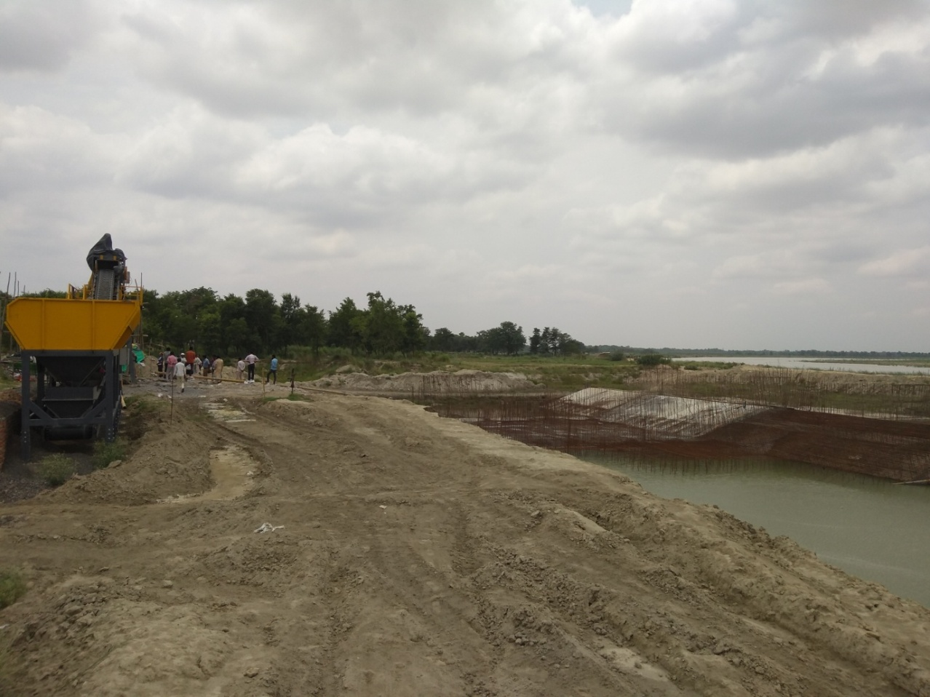
BR-52: Bagmati Flood Management Scheme Phase-IV- Construction of sluice

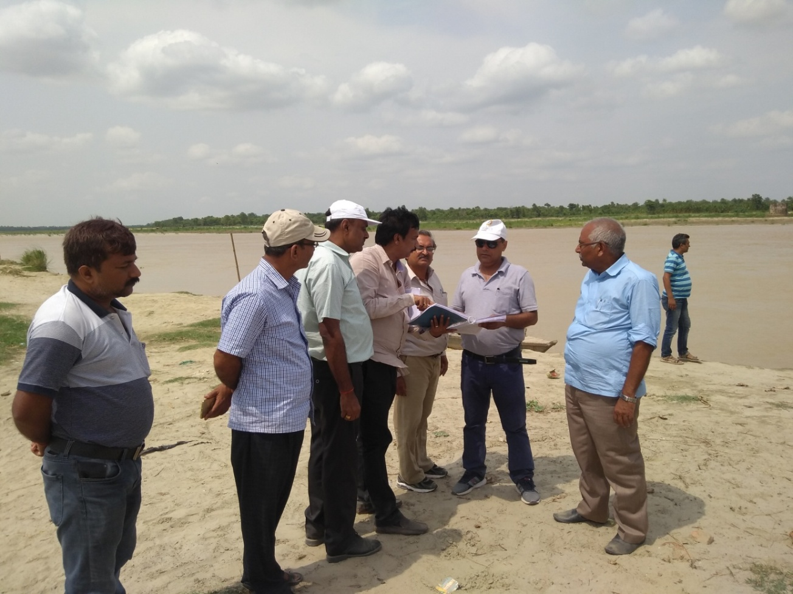
Visit to BR-52: Bagmati Flood Management Scheme Phase-IV

