GOVERNMENT OF INDIA
MINISTRY OF WATER RESOURCES
RIVER DEVELOPMENT & GANGA REJUVENATION
GANGA FLOOD CONTROL COMMISSION

Monitoring Report of scheme titled " Raising and Strengthening of Adhwara and Khiroi left Embankment from RD 0.0 km to Rd 43.60 km and from RD 44.00km to RD 90.50 km and Right embankment from RD 0.0 km to RD 81.50 km in Sitamarhi, Madhubani and Darbhanga districts of Bihar (BR-49) " under Flood Management Programme

Est. Cost : Rs. 13.3918 crore

Patna
JUNE, 2018

Monitoring Report of scheme titled " Raising and Strengthening of Adhwara and Khiroi left Embankment from RD 0.0 km to Rd 43.60 km and from RD 44.00km to RD 90.50 km and Right embankment from RD 0.0 km to RD 81.50 km in Sitamarhi, Madhubani and Darbhanga districts of Bihar (BR-49) " under Flood Management Programme
1. Introduction
The Adhwara basin comprises of north eastern part of Sitamarhi district, western part of Madhubani district and north western part of Darbhanga district. The area is covered by Pupri, Sonbarsa, Bajapatti, Bathnaha C.D. blocks of Sitamarhi district, Harlakhi, Madhopur, Basopatti, Benipatti, Bisfi, some part of Rahika-block of Madhubani district and Keoti, Jalley, Darbhanga, Singhwara, Bahadarpur and Hayaghat blocks of Darbhanga district.
This region is traversed by a network of rivers viz. Adhwara, Jamura Sikao, Burhand, Khiroi, Rato, Thomane, Biggi, Jamune, Dhaus and Darbhanga Bagmati. These rivers originate from the foot hills of Himalaya in Nepal and after traversing the area join together to form two distinct drainage channels namely Khiroi and Darbhanga Bagmati.
The vast fertile tract of Adhwara basin suffers from flood almost every year. In order to protect an area of about 141760 ha in Sitamarhi, Madhubani and Darbhanga districts of Bihar, Adhwara and Khiroi Embankments have been constructed. With passage of time, the river bed level increased due to siltation and top level of embankment got reduced due to wear and tear. In major reach of the existing embankments on these rivers, the existing top levels have become lower than design flood levels and hydraulic gradient lines have been exposed. The embankment section is so inadequate that it is not motorable even during dry season. Therefore, raising and strengthening of Adhwara and Khiroi embankments is essentially required for flood control in the area.
2. Details of Appraisal
The scheme “Raising and Strengthening of Adhwara and Khiroi left Embankment from RD 0.0 km to Rd 43.60 km and from RD 44.00 km to RD 90.50 km and Right embankment from RD 0.0 km to RD 81.50 km in Sitamarhi, Madhubani and Darbhanga districts of Bihar (BR-49)“ for an estimated cost of Rs. 6703.00 lakh, was accepted by the Advisory Committee on Irrigation, Flood Control and Multipurpose Projects in its meeting held on 28th March, 2012. The investment clearance of the scheme was given by Planning Commission vide its letter No. 12(1)4/2008-WR dated 24.09.2012. The scheme was taken up for implementation under State Sector Flood Management Programme (FMP) with 75% of the cost to be provided by Government of India as central assistance.

The scheme was accepted by Inter Ministerial Committee in its 1st meeting held on 19.12.2013 for estimated cost of Rs. 16703.00 lakhs out of which the central assistance would be Rs. 12527.00 lakh. However, as per phasing indicated by the State Government, the proposed expenditure during 2013-14 was Rs. 6726.17 lakh. As such, estimated cost eligible for funding under FMP was considered as Rs. 6726.17 lakh with corresponding Central share as Rs. 5044.63 lakh. The remaining expenditure was to be borne by State Government. An amount of Rs. 2522.32 lakh has been released so far by Govt. of India as 1st installment of central assistance vide MoF letter no. 41(4)/PF-1/2013- 1792 dated 31.03.2014.

2. Project proposal

Raising and strengthening of Adhwara & Khiroi left and right embankments consist of following components:

- Raising and strengthening of left embankment of river Adhwara from Sonbarsa village to Agropatti (RD 0.0 km to Rd 4.060 km) in a length of 43.60 km

- Raising and strengthening of right embankment of river Adhwara from Sonbarsa village to Makia (RD 0.0 km to Rd 44.00 km) in a length of 44.00 km

- Raising and strengthening of left embankment of river Khiroi from Agropatti to Ekmighat (RD 44.00 km to RD 90.50 km) in a length of 46.50 km

- Raising and strengthening of right embankment of river Khiroi from Makia to NH-57 (RD 44.00 km to RD 81.50 km) in a length of 37.50 km

- Construction of anti flood sluice-75 nos. (40 nos. in Adhwara portion and 35 nos. in Khiroi portion)

- Construction of ramps-50 nos. (24 nos. in Adhwara portion and 26 nos. in Khiroi portion)

- Repair of ramps -10 nos. in Khiroi portion.

4. Site Inspection
The site was inspected by officers of GFCC, Patna on 8th and 9th June 2018 along with State Government Engineers. The following engineers from GFCC, Patna and WRD, Govt. of Bihar were present during the inspection.

Officers from GFCC, Patna

- Shri Ajay Kumar, Director, GFCC
- Shri Sanjeev Kumar, Dy. Director, GFCC
- Shri O. P. Singh, Asstt. Director, GFCC

Officers from WRD, Government of Bihar

- Shri Rabindra Kumar, SE, Flood Control Circle, Sitamarhi
- Shri Jitendra Kumar, E.E., Bagmati Flood Control Division,Sitmarhi.
- Shri Binay Kumar, A.E., Bagmati Flood Control Division,Sitmarhi.
The sites inspected are described below:
- Right Adhwara embankment from RD 14 to 15 km. near Bajpatti
- Adhwara left embankment from RD 14 to 15 km. near Basha
- Right Adhwara embankment from RD 18 to 20 km. near Badhuban Bazar.

As reported by the WRD, Bihar officials, the project is to be completed by March 2019. Phasing of expenditure as submitted by the State Govt is enclosed as Annex-I.

5. Quality Control Measures
The officers of WRD, Govt. of Bihar have taken Quality Control Measures during the construction of embankment. The sample of concrete cube were taken and tested in Irrigation Research Institute, Khagaul, Patna. The sample test report made available by WRD, Govt. of Bihar is enclosed at Annex-II.

6. Photographs
The photographs of the sites were taken during inspection and some photographs were collected from the officers of State Govt. which were taken during execution of works. These photographs are enclosed as Annex-III.

7. Present Status and Bottlenecks

The actual construction of scheme was started in the year 2012. As per information provided by WRD Bihar, the scheme is approximately 86 % complete. The reasons for delay are encroachment along the embankment, scarce availability of earth material & unusual demand of compensation, difficult approach, frequent flooding in the area etc.
8. Status of Release of Central Assistance
Amount in Rs. Crore
I | Estimated Cost |  | 167.0300
II | Central Share |  | 125.2700
III | Eligible Central Share |  | 50.4463
IV | Central Share Released | Year | Amount
 | 1st Installment | 2013-2014 | 25.2232
 | Total release |  | 25.2232
V | Balance Central Share to be released |  | 25.2231

9. Recommendation/Conclusion
The works are being carried out satisfactorily. However, the progress of the work is slow and needs to be expedited. WRD Bihar has to make special and dedicated effort to clear encroachment on embankment in consultation with district administration and ensure the availability of suitable earth material so as to complete the work by March 2019.
Based on the field visit, discussions with concerned official of WRD Bihar and information furnished by them the aforesaid scheme may be continued under FMP and the next installment of Central share may be released.

(Ajay Kumar)
Director(P&C)
GFCC, Patna
ANNEX-III
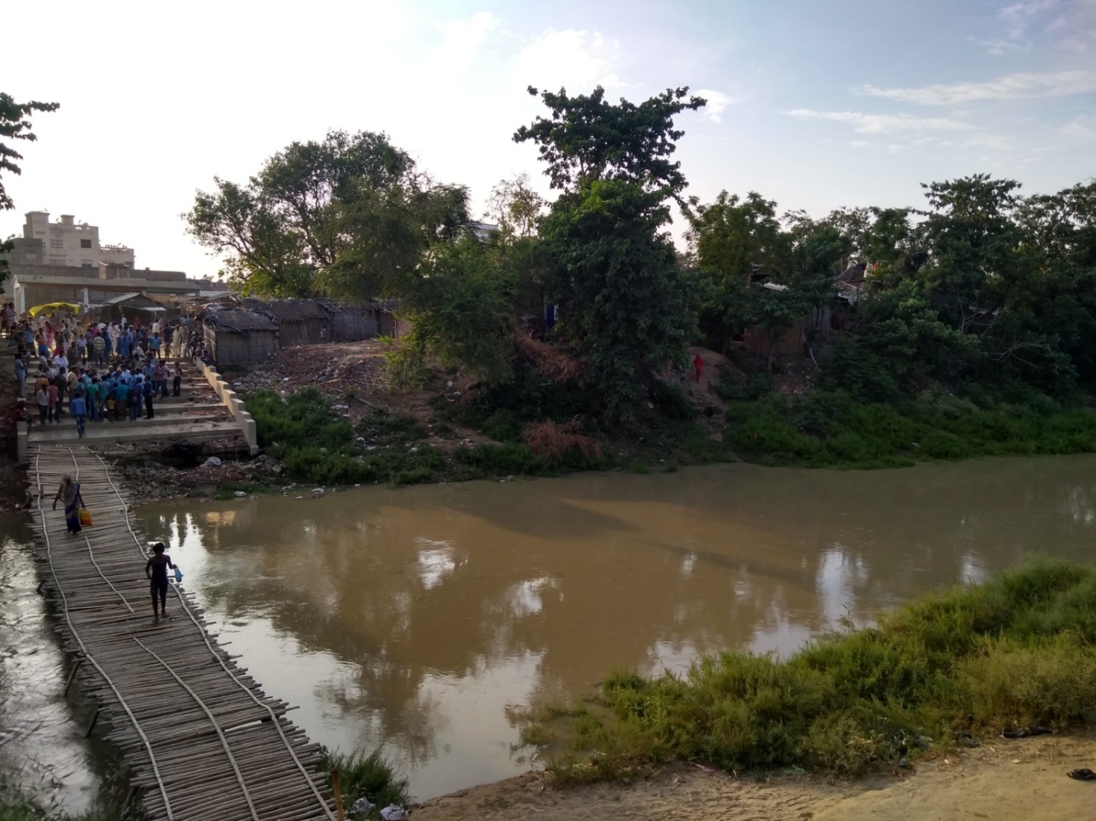
BR-49: Raising and Strengthening of Adhwara and Khiroi Embankment
(Discussions with project officials and local people at Bajpatti village)

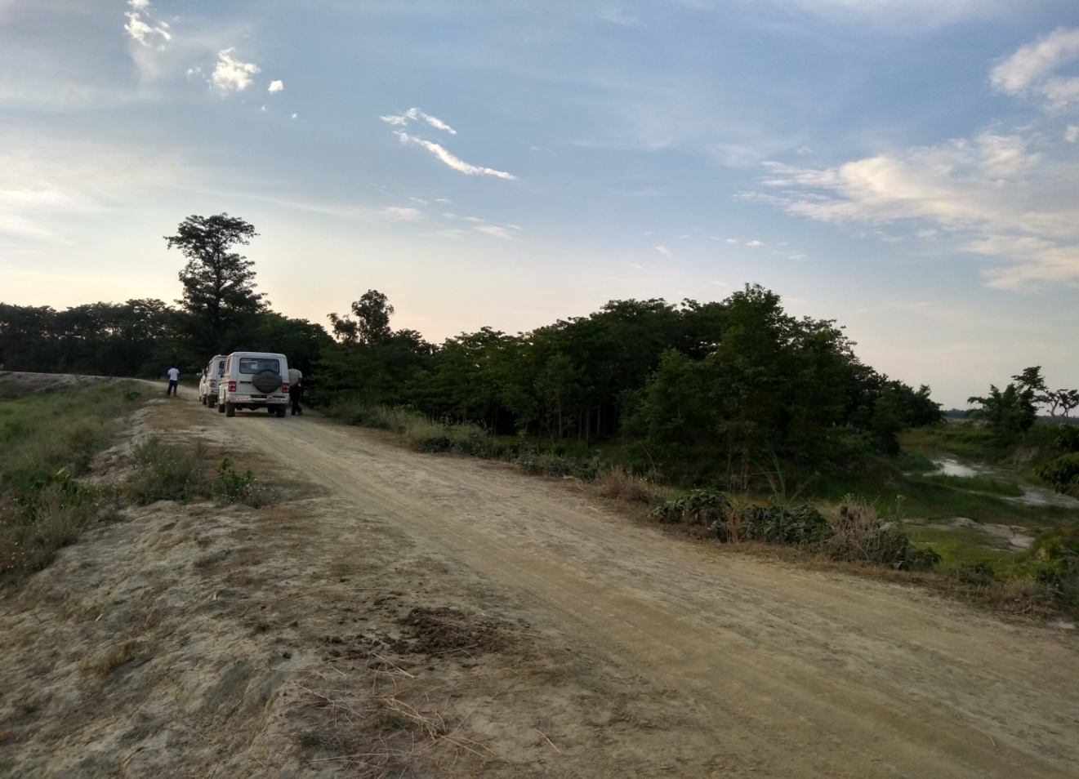
BR-49: Raising and Strengthening of Adhwara and Khiroi Embankment (Right)

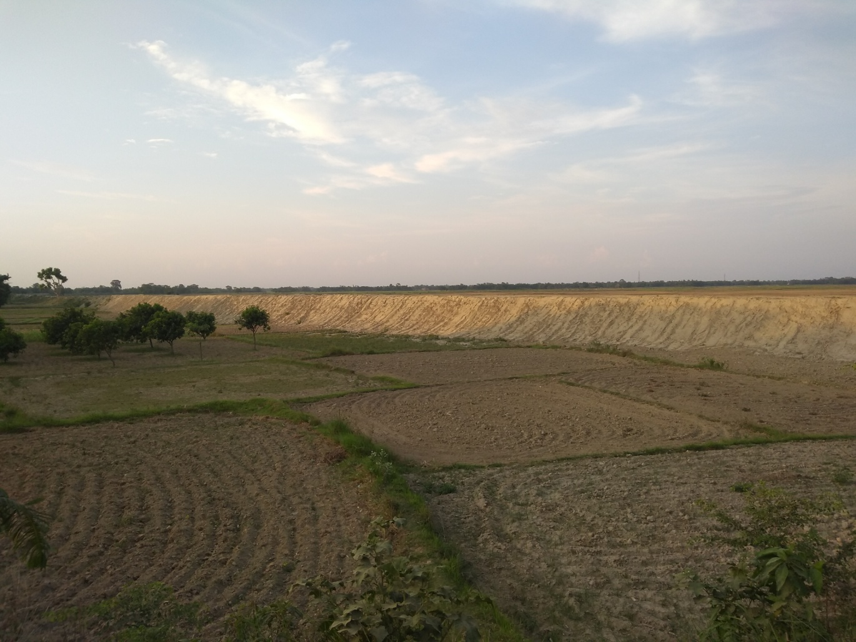
BR-49: Raising and Strengthening of Adhwara and Khiroi Embankment (Left)

